Year 2 Homework
4.12.20
Draw pictures to match the repeated addition sums. You could draw coins, animal ears or anything you like!

2 + 2 + 2 + 2 = | 5 + 5 + 5 = | 3 + 3 + 3 + 3 + 3 + 3 =
4 + 4 + 4 + 4 + 4 = | 6 + 6 + 6 = | 2 + 2 + 2 = 6  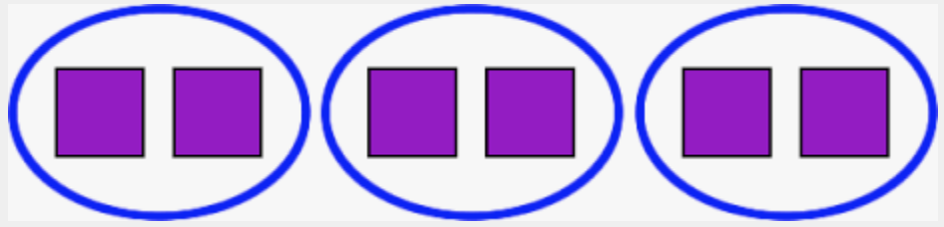  3 x 2 = 6
8 + 8 + 8 = | 5 + 5 = | 4 + 4 + 4 + 4 =
Challenge: Can you write multiplication sentences to match? I have done one to show you.

