Year 2 Homework
27.11.20

Remember cafes? They were fun.
Let’s pretend lockdown 2 is over and your teachers can go out for lunch!

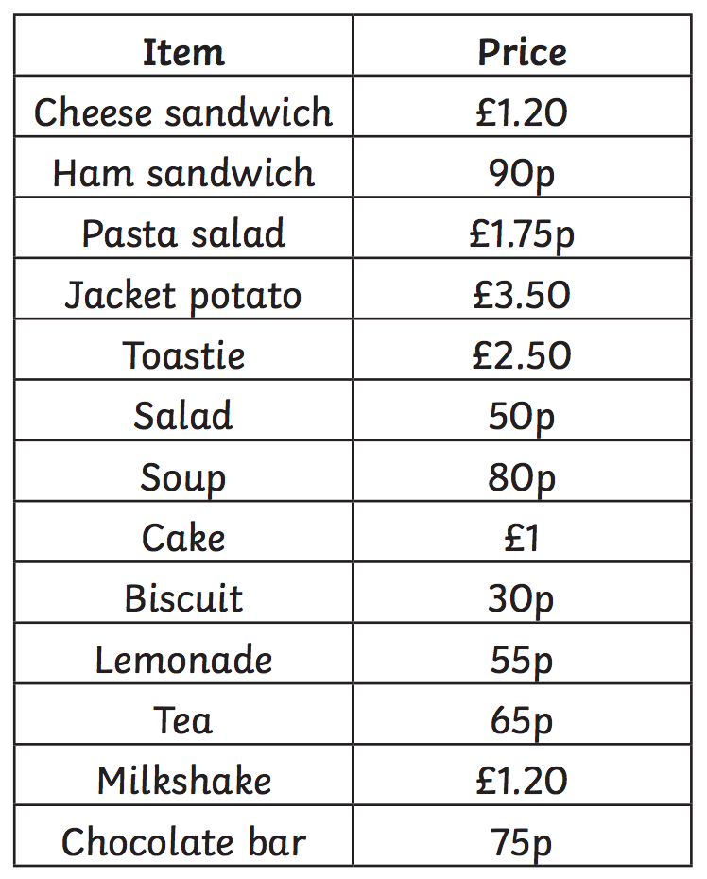

What is the most expensive thing on the menu? ________________

What is the cheapest thing on the menu? ________________

Pauline orders a toastie and a biscuit. How much is her bill?

Shyma orders a cheese sandwich and lemonade. How much is her bill?

Aoife orders soup and cake. How much is her bill?

Choose two things that you would like to order. How much is your bill?

