Answer these division questions by grouping the counters on your table! Show me your jottings.

Kian has 10 football stickers. He shares them between his 2 friends. How many stickers do they get each?

Lottie has 15 sweets. She shares them between 5 children. How many sweets does each child get?

Katie has 12 dolls. She shares them between 2 of her friends. How many dolls do they have each?

There are 24 books in total and they are packed in boxes of 3. How many boxes are there?

18 flowers are shared between 2 vases. How many flowers go in each vase?

The milkman has 25 bottles of milk, if he delivers 5 bottles to each house, how many houses will he deliver to?

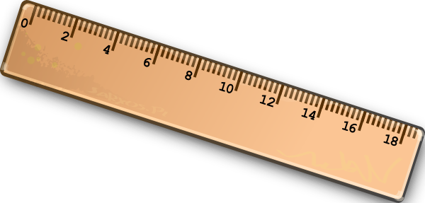
Mrs Evans decided to share 60 rulers out between her group of 10 children, how many rulers did each child get?

