Dear Parents,
Please see some of the events that will be taking place over the Spring and Summer terms in 2020
Spring Term 2020
Parents Meetings – Reception and Year 6
Make a note of the dates for parent meetings with teachers for Reception and Year 6 classes
- Tuesday 24th March 2020 – RECEPTION Parent Meetings
- Wednesday 25th March 2020 – YEAR 6 Parent Meetings
Achievement Assembly
Friday 3rd April at 9.10 AM
We’ll let you know when you can sign up for a ticket
Summer Term 2020
Coffee Morning with GLL
On Tuesday 28th April, Shelly will be hosting a special coffee morning with Greenwich Leisure Limited, who will be talking about swimming activities and facilities in Tower Hamlets
Meet Shelly at 9.00 in the Parents Room the ground floor.
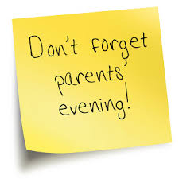
PARENTS EVENINGS – all classes
- Tuesday 28th April 2020
- Wednesday 29th April 2020
- Tuesday 5th May 2020
Summer Celebration
Friday 26th June 2020
Join us in the school playground at 2PM for our annual celebration. More details to follow.

