THE TROY TIMES
THE PEOPLE’S FAVOURITE NEWSPAPER £1

Headline goes here… alliteration would be fun

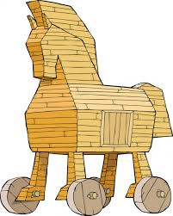
The night of the attack
What happened the night of the attack?

Quotes?

What happens now?
What will happen next? Will Troy respond?

Safety of the city
Why did the Spartans change the way they attacked the city?

Beware of gifts
How did they change the plans? What did the Trojans think?
Complete the beginning by saying:
Who
What
Where
When

Why did this happen?
How did the conflict start?
The last image of the deadly ‘gift’ left by the Spartans

