Malala opening

“ Let's stay on for the second bus,” said Moniba, my best friend. “That way we can chat a little longer.” We always like to stay on the bus for the late pick-up.

For days I've had a strange knowing feeling that something bad was going to happen. One night I found myself wondering about death. “What is being dead really like?”
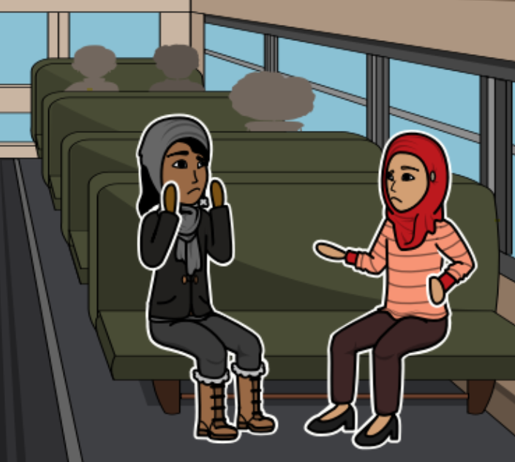
I wanted to know. I was alone in my room so I turned towards Mecca and asked God, “What happens when you die?” I said. “How would it feel?”

If I died, I wanted to be able to tell people what it felt like.
“Malala you silly girl,” I said to myself then “You'd be dead and you couldn't tell people what it was like.”

Say before I went to bed I asked God one more thing, “Can I die a little bit and come back so I can tell people about it”. But the next day had dawned bright and sunny and so had the next one and the one after that and now I knew I did well in my exam, whatever cloud had been hanging over my head had begun to clear away. So Moniba and I did what we always did: we had a good gossip. What face cream was she using? Had one of the male teachers gone for a baldness cure? And, now, the first exam was over, how difficult would the next one be?

When our bus was called, we ran down the steps. As usual, Moniba and the other girls covered their heads and faces before we stepped outside and the gate and got into the waiting dyna, the white truck that was our Khushal School ‘bus’. And, as usual our driver was ready with a magic trick to amuse us. That day he made a pebble disappear. No matter how hard we tried we couldn’t figure out his secret.

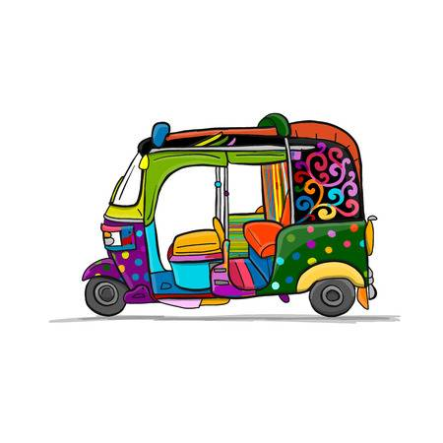
We piled inside, twenty girls And two teachers crammed into the three rows of benches stretching down the length of the dyna. It was hot and sticky and there were no windows, just a yellow plastic sheet that flat against the side as we bounced along Mingora’s crowded rush- hour streets.

Haji Baba was a jumble of brightly coloured rickshaws, women in flowing robes, men on scooters honking and zigzagging through the traffic. We passed the shopkeeper butchering chickens, a boy selling ice cream cones.
Moniba and I were in deep conversation. I had many friends but she was a friend of my heart, the one with whom I shared everything.
That day we were talking about who would get the highest marks this term when one of the other girls started the song and the rest of us joined in.
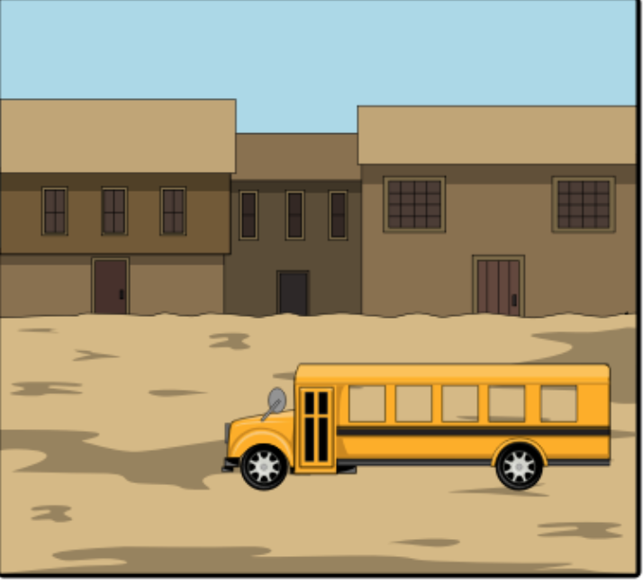

Just after we passed the little Giants snack factory and the bend in the road not more than 3 minutes from my house, the van slowed to a halt. It was oddly quiet inside.

“It's so calm today,” I said to Moniba. “Where are all the people?”
I don't remember anything after that but here's the story that's been told to me.
Two young men in white robes stepped in front of a truck.

“Is the Khushal school bus?” one of them asked.
The driver laughed. The name of the school was painted in black letters on the side of the van. the other young man jumped onto the tailboard and leaned into the back where we were all sitting.
“Who is Malala?” he asked.

No one said a word but if you guys looked in my direction. He raised his arm and pointed at me. Some of the girls screamed. I screamed at Moniba
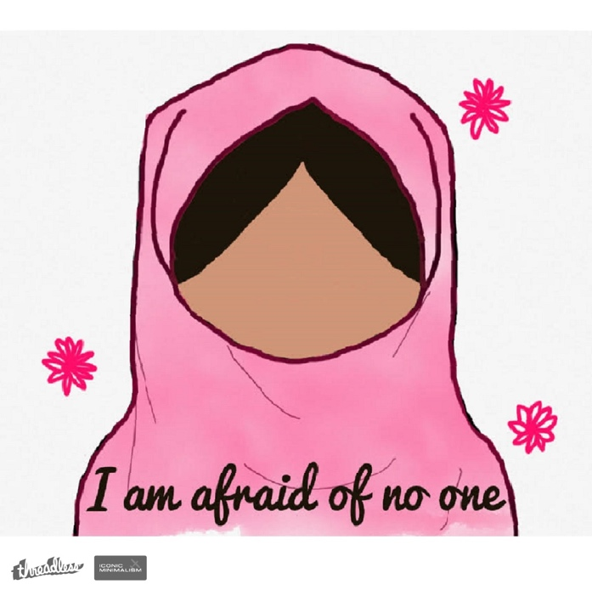

Who is Malala?

I am Malala and this is my story.

