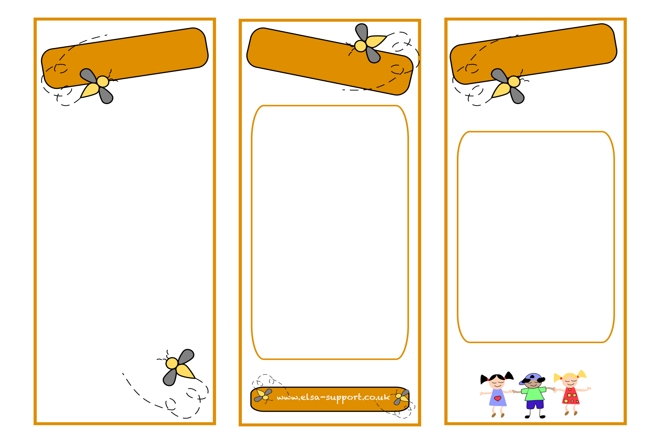

An ELSA is a specialist teaching assistant with a wealth of experience of working with children. ELSAs are trained and regularly supervised by the Educational Psychologists in your Local education authority. An ELSA is a warm and caring person who wants to help your child feel happy in school and to reach their potential educationally. Their aim is to remove the barriers to learning and to have happy children in school and at home.

Please do talk to the ELSA in your school if you have any problems with your child.

**Loss and bereavement**

**Self-esteem**

**Social skills**

**Emotions**

**Friendship issues**

**Relationships**

**Anger management**

**Behaviour**

**Anxiety**

**Bullying**

**Conflict**

**Relaxation techniques**

**E**motional

**L**iteracy

**S**upport

**A**ssistant

**ELSA**

**What is an ELSA**

**ELSAs can help with**

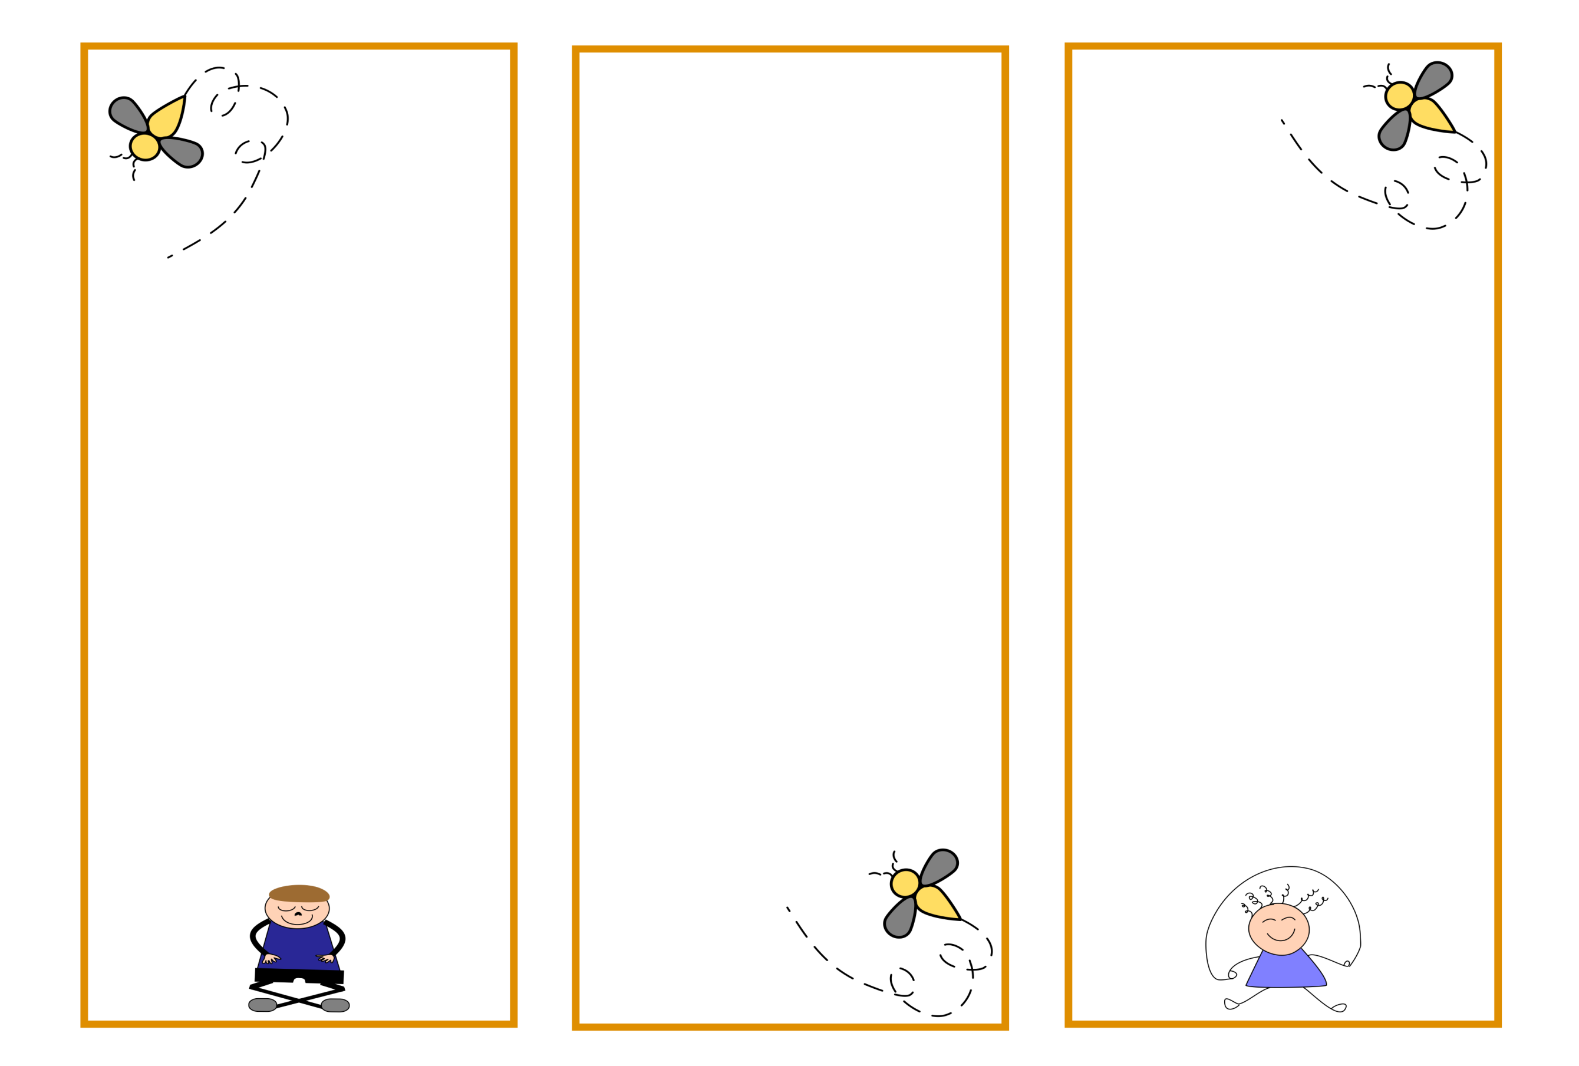

**A loved pet has died**

ELSAs are trained in bereavement and understand that the loss of a pet is probably the first experience of death for your child. They will work with your child to help them feel supported in school.

**A very angry child**

The ELSA will take the child through an anger management intervention to help them recognise their anger triggers, techniques to avoid those triggers and calming down techniques.

The ELSA will plan their sessions for your child very carefully. The session consists of several parts, the first two parts consists of a circle-time where children sit in a circle and take turns to speak.

Emotional check in

This is an opportunity to talk about feelings,

Warm up activity

A fun game or activity to help relax your child.

Main activity

This is similar to the individual session but your child will be encouraged to work with other children. This helps with co-operation, social skills, friendship and gives a sense of belonging. A learning objective will be set for the group of children which they will all be able to answer at the end of the session.

Relaxation

Your child will be taught a relaxation exercise to help get them ready to go back to class

The ELSA will plan their sessions for your child very carefully. The session consists of several parts.

Emotional check in

This is an opportunity to talk about feelings,

Main activity

The ELSA will plan the activity to a learning objective. Something your child will be able to do at the end of the session that they cannot do now. This is usually a ‘I can ‘ statement such as ‘I can tell you about my strengths’ (A self-esteem objective). The ELSA will encourage your child to tell you about their talents or personal characteristics such as ‘kind’, ‘caring’, ‘helpful’ or ‘brave’. The child will then make something to reinforce those strengths.

Relaxation

Your child will be taught a relaxation exercise to help get them ready to go back to class

Your child will now be able to answer the question ‘I can tell you about my strengths’

Typical problems

Group session

Individual session